Lab 10 MVC Architecture and PHP Framework
Lab 10 MVC Architecture and PHP Framework 1
10.1 A simple MVC project in PHP 2
10.2 Build your own PHP MVC Framework 6

A simple MVC project in PHP
Flolder
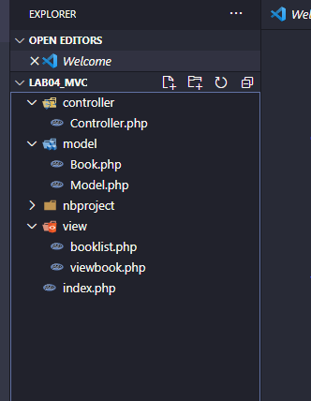
Demo:
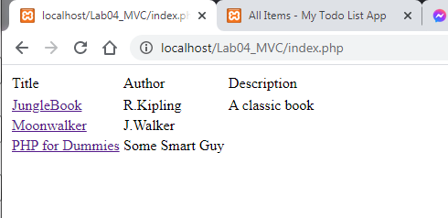
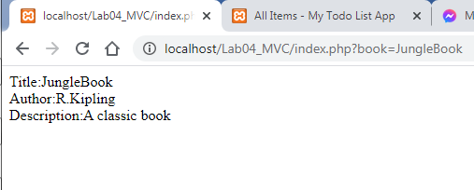

Build your own PHP MVC Framework

Part 1 – Some basic components
The Directory Structure
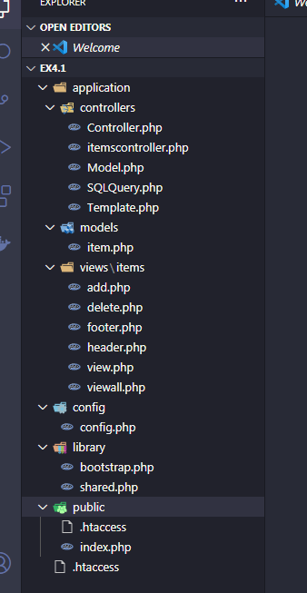
Demo
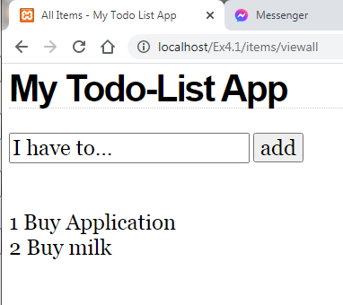
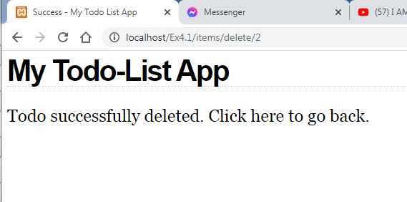
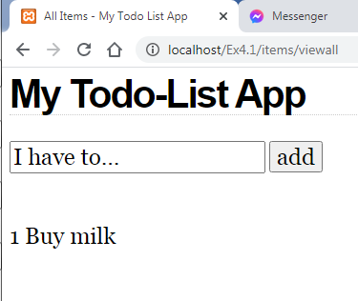

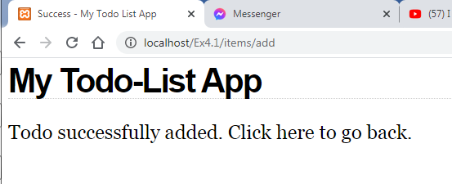
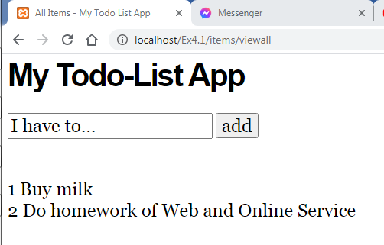

Part 2 – Simple e-commerce website
Tạo csdl trên phpMyAdmin
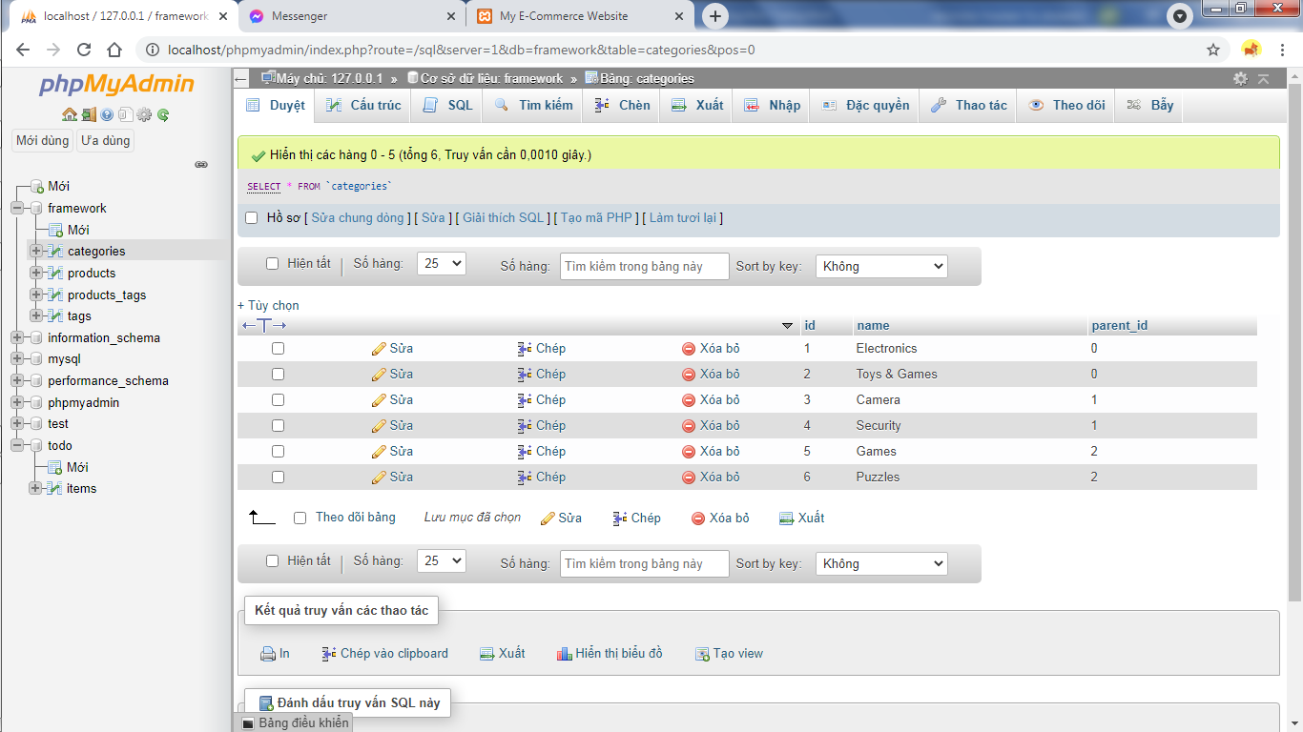

Chạy demo:

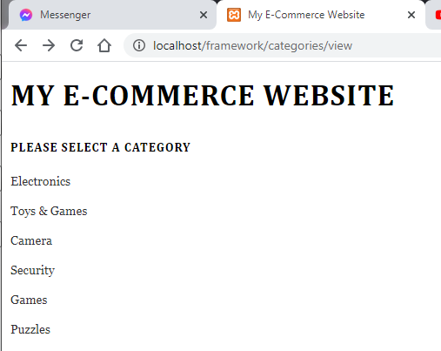
Sau khi chọn Category: Electronics
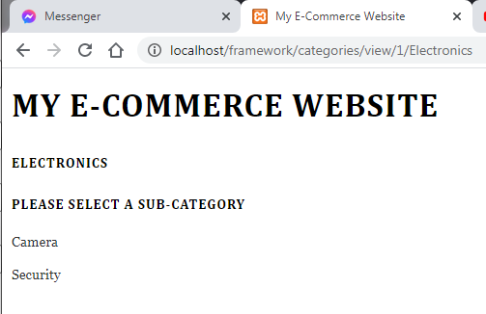

Sau khi chọn Subcategory: Camera
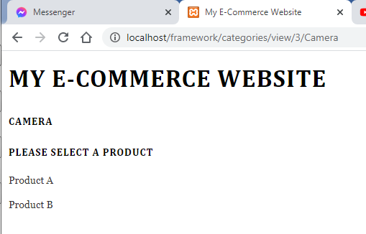
Sau khi chọn Product A:
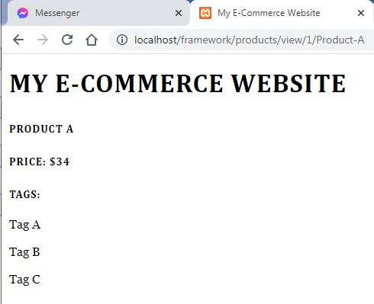
Hoặc chọn Product B:
